UNIT-5
EXPERIMENT 1

AIM: To implement exception handling in C++ using try, catch, and throw for handling runtime errors.

DESCRIPTION:
This program shows how to handle errors in C++ using try, catch, and throw. If a problem occurs (like dividing by zero), the program throws an exception, which is caught and handled without stopping the program suddenly. It helps make the program run safely even when errors happen.

PROGRAM:
#include <iostream>
#include <stdexcept> // Needed for runtime_error using namespace std;
int main() {
int numerator, denominator; cout << "Enter numerator: "; cin >> numerator;
cout << "Enter denominator: "; cin >> denominator;
try {
if (denominator == 0) {
throw runtime_error("Division by zero is not allowed!");
}
double result = static_cast<double>(numerator) / denominator; cout << "Result = " << result << endl;
}
catch (const runtime_error &e) {
cout << "Exception caught: " << e.what() << endl;
}

cout << "Program continues after exception handling..." << endl; return 0;
}

OUTPUT:
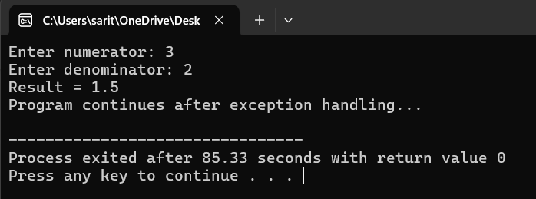
RESULT:
The program successfully handles runtime errors by detecting invalid operations and throwing appropriate exceptions. Instead of terminating abruptly, it displays a clear error message through the catch block and allows the program to continue executing smoothly.

EXPERIMENT 2
AIM: To write a C++ program that demonstrates the use of multiple catch statements for handling different types of exceptions.

DESCRIPTION:
This program shows how to handle different types of errors in C++ using multiple catch statements. When an exception is thrown, the program checks each catch block to find one that matches the type of error. This allows the program to respond differently to various kinds of exceptions, such as integer errors, character errors, or string errors. It helps make the program more flexible and able to handle multiple error situations properly.

PROGRAM:
#include <iostream> using namespace std; int main() {
try {
int choice;
cout << "Enter 1 for int exception, 2 for float exception, 3 for string exception: "; cin >> choice;
if (choice == 1)
throw 10; // Integer exception else if (choice == 2)
throw 3.14f; // Float exception else if (choice == 3)
throw "Hello"; // String exception else
throw 'X'; // Character exception
}
catch (int e) {
cout << "Caught an integer exception: " << e << endl;
}
catch (float e) {
cout << "Caught a float exception: " << e << endl;

}
catch (const char* e) {
cout << "Caught a string exception: " << e << endl;
}
catch (...) {
cout << "Caught an unknown exception!" << endl;
}
cout << "Program continues after exception handling." << endl; return 0;
}

OUTPUT:
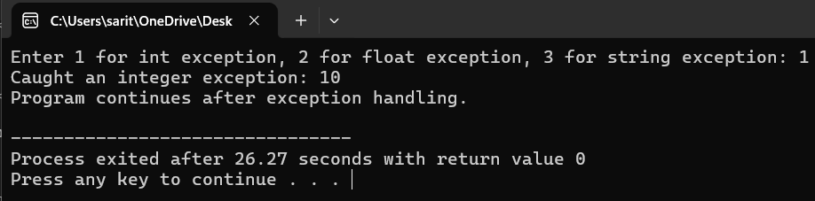
RESULT:
The use of multiple catch statements enabled the program to react appropriately to various kinds of exceptions. Depending on whether an integer, character, or string was thrown, the corresponding catch block was executed, proving that C++ can efficiently distinguish and manage multiple error types within the same try block.

EXPERIMENT 3
AIM: Program to implement List, Vector and perform basic operations using the STL (Standard Template Library) in C++.

DESCRIPTION:
This program demonstrates how to use the List and Vector containers from the C++ Standard Template Library (STL). It shows how to perform basic operations such as inserting, deleting, accessing, and traversing elements. The Vector provides dynamic array functionality, while the List offers efficient insertion and deletion at any position. This program helps understand the usage, differences, and advantages of these STL containers in managing collections of data easily and efficiently.

PROGRAM:
#include <iostream> #include <vector> #include <list>
using namespace std; int main() {
// Vector operations vector<int> v; v.push_back(10); v.push_back(20); v.push_back(30);
cout << "Vector elements: "; for (int i = 0; i < v.size(); i++)
cout << v[i] << " ";
cout << "\nSize: " << v.size() << ", Capacity: " << v.capacity() << endl; v.pop_back();
cout << "After pop_back, Vector elements: "; for (auto it = v.begin(); it != v.end(); ++it)
cout << *it << " "; cout << endl;
// List operations

list<int> l; l.push_back(100); l.push_front(50); l.push_back(150);
cout << "\nList elements: ";
for (auto it = l.begin(); it != l.end(); ++it) cout << *it << " ";
l.remove(100); // Remove element
cout << "\nAfter removing 100, List elements: "; for (int x : l)
cout << x << " "; cout << endl;
return 0;
}

OUTPUT:
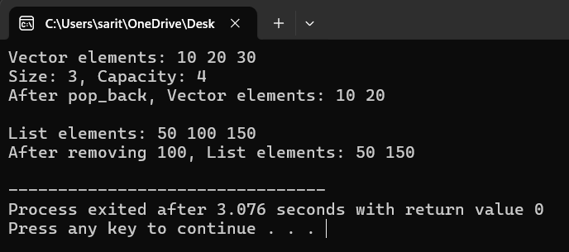
RESULT:
The program successfully performs insertion, deletion, and traversal operations using both list and vector containers from the STL.
It clearly shows the sequential nature of vectors and the flexible insertion capability of lists. Overall, the STL provides an efficient and user-friendly way to manage dynamic data structures in C++.

EXPERIMENT 4
AIM: To write a C++ program to implement a Deque (Double-Ended Queue) and perform various operations such as insertion and deletion from both ends.

DESCRIPTION:
This program demonstrates how to implement and use a Deque (Double-Ended Queue) in C++ using the Standard Template Library (STL). A deque allows insertion and deletion of elements from both the front and the rear ends efficiently. The program performs various operations such as adding elements to both ends, removing elements from both ends, and displaying the contents of the deque. It helps understand how deques provide flexibility in managing data from both sides of the sequence.

PROGRAM:
#include <iostream> #include <deque> using namespace std; int main() {
deque<int> dq;
// Insert elements dq.push_back(10); // Insert at rear dq.push_back(20); dq.push_front(5); // Insert at front
cout << "Deque elements: "; for (int x : dq) {
cout << x << " ";
}
cout << endl;
// Access elements
cout << "Front element: " << dq.front() << endl; cout << "Back element: " << dq.back() << endl;
// Deletion
dq.pop_front(); // Remove front element dq.pop_back(); // Remove rear element

cout << "Deque after deletion: "; for (int x : dq) {
cout << x << " ";
}
cout << endl;
// Insert more elements dq.push_front(100); dq.push_back(200);
cout << "Deque final state: "; for (int x : dq) {
cout << x << " ";
}
cout << endl; return 0;
}

OUTPUT:
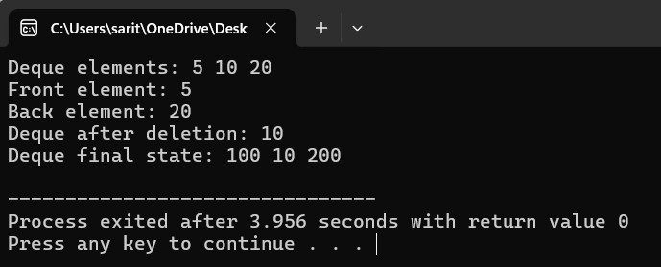
RESULT:
The program successfully demonstrates insertion and deletion of elements from both the front and rear ends of the deque.
Each operation executes correctly, showing the flexibility of the deque container in handling data from both sides.
Overall, it proves that the STL deque is an efficient structure for double-ended data manipulation in C++.

EXPERIMENT 5
AIM: To write a C++ program that demonstrates the implementation of a map container and performs various operations such as insertion, traversal, search, deletion, and size check.

DESCRIPTION:
This program demonstrates the use of the map container in C++ using the Standard Template Library (STL). A map stores data in key-value pairs, where each key is unique and automatically sorted. The program performs various operations such as inserting elements, traversing the map to display all key-value pairs, searching for a specific key, deleting an element, and checking the size of the map. It helps understand how maps are useful for efficient data storage and retrieval based on unique keys.

PROGRAM:
#include <iostream> #include <map> #include <string> using namespace std; int main() {
// Declare a map with key as int and value as string map<int, string> student;
// Insertion
student[1] = "Alice"; student[2] = "Bob"; student.insert({3, "Charlie"}); student.insert({4, "David"});
cout << "Map Elements (Key -> Value):" << endl;
for (auto it = student.begin(); it != student.end(); ++it) { cout << it->first << " -> " << it->second << endl;
}
// Searching an element int key = 3;
auto it = student.find(key); if (it != student.end()) {

cout << "\nFound: " << it->first << " -> " << it->second << endl;
} else {
cout << "\nKey " << key << " not found." << endl;
}
// Deleting an element student.erase(2);
cout << "\nAfter deleting key 2:" << endl; for (auto &pair : student) {
cout << pair.first << " -> " << pair.second << endl;
}
// Size of the map
cout << "\nSize of the map: " << student.size() << endl; return 0;
}

OUTPUT:
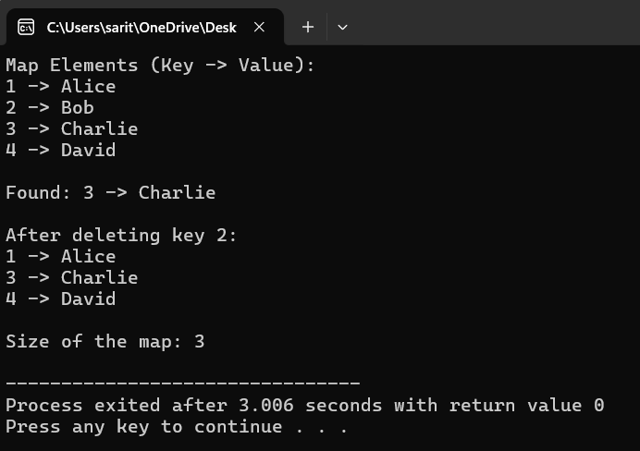
RESULT:
The program successfully inserts, traverses, searches, and deletes key-value pairs using the map container.
The size of the map is accurately updated after each operation, confirming efficient data management.
Overall, the implementation proves that the STL map is highly effective for structured and searchable data storage in C++.

